Assignment Day 2

Question - Mobile phone

using System;

using System.Collections.Generic;

using System.Linq;

using System.Text;

using System.Threading.Tasks;

namespace Training_Day2

{

abstract class MobPhone

{

abstract public void Call();

abstract public void Cam();

}

class Nokia1400 : MobPhone

{

public override void Call()

{

Console.WriteLine("In Nokia1400 Call function is available ");

}

public override void Cam()

{

Console.WriteLine("In Nokia1400 Cam function is not available");

}

}

class Nokia2700 : MobPhone

{

public override void Call()

{

Console.WriteLine("Nokia2700 Call function is available");

}

public override void Cam()

{

Console.WriteLine("Nokia2700 cam function is available");

}

}

class Blackberry : MobPhone

{

public override void Call()

{

Console.WriteLine("Blackberry Call function is available");

}

public override void Cam()

{

Console.WriteLine("Blackberry Cam function is available");

}

}

class MobileFeatures

{

public static void Main()

{

MobPhone mp = new Nokia1400();

mp.Call();

mp.Cam();

mp = new Nokia2700();

mp.Call();

mp.Cam();

mp = new Blackberry();

mp.Call();

mp.Cam();

}

}

}

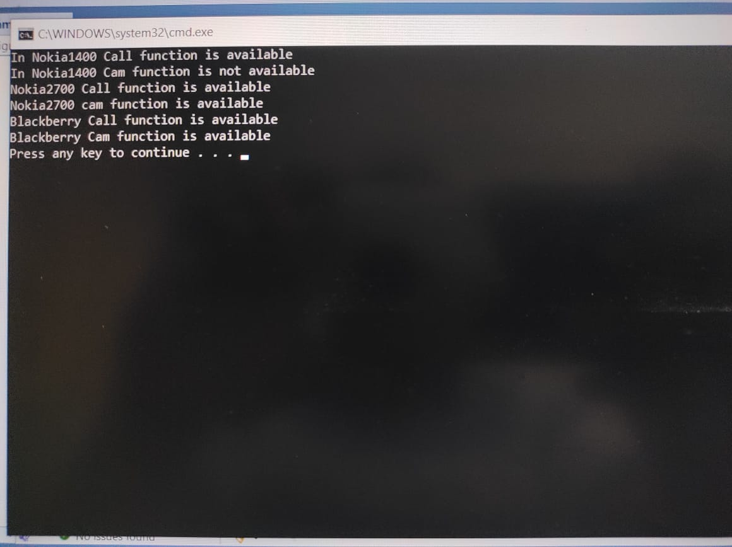

Question single level inheritance

using System;

using System.Collections.Generic;

using System.Data;

using System.Linq;

using System.Net;

using System.Text;

using System.Threading.Tasks;

using System.Xml.Linq;

namespace Training_Day2

{

class Person

{

string Name = "Shubham Kote";

string add = "SHIRDI";

public void Show()

{

Console.WriteLine("Person Name = " + Name ) ;

Console.WriteLine("Address = " + add ) ;

}

}

class Employee : Person

{

int eno = 101;

string designation = "Data Engg";

string location = "Pune";

public void profile()

{

Console.WriteLine("Employee No = :" + eno);

Console.WriteLine("Designation = :" + designation);

Console.WriteLine("Location = " + location);

}

}

class Emplinfo

{

public static void Main()

{

Employee e = new Employee();

e.Show();

e.profile();

}

}

}

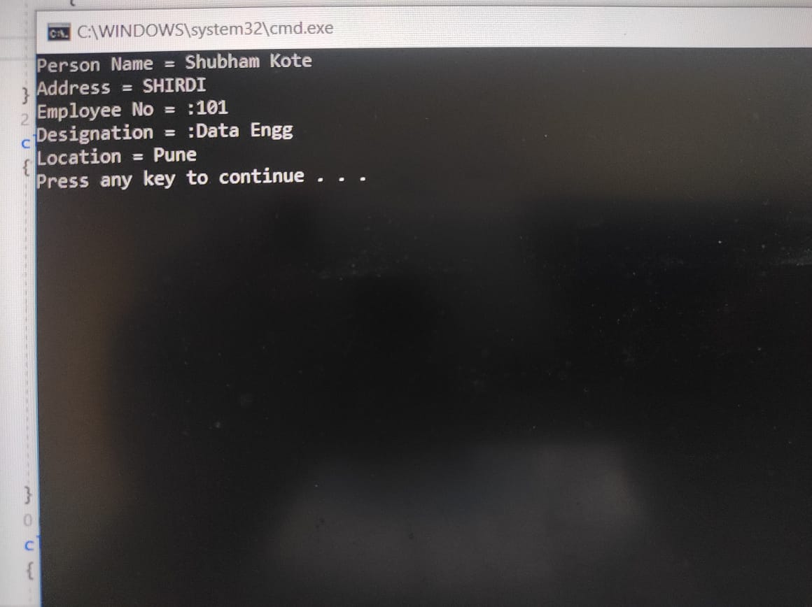

Q employee

using Employee;

using System;

using System.Collections.Generic;

using System.Linq;

using System.Text;

using System.Threading.Tasks;

namespace Employee

{

public class Employe

{

public int empid;

public string empname;

public string add;

public string city;

public string edept;

public double sal;

public void GetEmployeData(int id, string name, string addres, string cty, string dept, double salry)

{

empid = id;

empname = name;

add = addres;

city = cty;

edept = dept;

sal = salry;

}

}

}

//Employee

namespace assignmentDay2

{

internal class Assignment

{

public static void Main()

{

double[] sal = new double[5];

string[] nam = new string[5];

Employe e = new Employe();

for (int i = 0; i < 4; i++)

{

Employe t = new Employe();

Console.WriteLine("Enter Emp id:");

t.empid = Convert.ToInt32(Console.ReadLine());

Console.WriteLine("Enter Emp Name:");

t.empname = Console.ReadLine();

nam[i] = t.empname;

Console.WriteLine("Enter Emp address:");

t.add = Console.ReadLine();

Console.WriteLine("Enter Emp city:");

t.city = Console.ReadLine();

Console.WriteLine("Enter Emp department:");

t.add = Console.ReadLine();

Console.WriteLine("Enter Emp salary:");

t.sal = Convert.ToDouble(Console.ReadLine());

sal[i] = t.sal;

}

for (int i = 0; i < 4; i++)

{

Console.WriteLine("Employee name:" + nam[i] + " " + "Salary=" + sal[i]);

}

}

}

}

